SmartDose: Advancing Medication Adherence in Older Adults
By Brad G. Philbrick, RPh
(Based on a realistic composite scenario. Names and proprietary identifiers have been adapted for confidentiality.)

Background / Challenge
Medication nonadherence remains one of the most preventable causes of hospitalization among older adults. Studies estimate that up to 50% of patients do not take medications as prescribed, leading to increased morbidity, healthcare costs, and diminished quality of life.
A biomedical startup, SmartDose Technologies, sought NIH SBIR Phase I funding to prototype an intelligent medication adherence device designed for seniors living independently. Despite a promising concept, the team needed help transforming its engineering-heavy proposal into a clinically relevant, fundable narrative that emphasized patient outcomes, public health impact, and commercial potential.

Solution / Approach
I collaborated closely with the CEO, lead engineer, and a geriatric clinical advisor to reshape the proposal around a central theme: empowering older adults through innovative, simplified medication management.
Key steps included:
1. Clarifying the Problem Statement – Reframing adherence as both a behavioral and systemic challenge, supported by NIH-cited data.
2. Integrating Clinical Perspective – Translating technical device features (reminder alerts, dosage tracking, caregiver connectivity) into measurable health outcomes.
3. Visualizing Impact – Designing tables and outcome metrics to make projected results easy to interpret for reviewers.
4. Strengthening Commercial Viability – Framing SmartDose as a scalable, Medicare-aligned innovation with strong market entry potential.

Results / Outcomes
After submission, the SmartDose Phase I proposal received a high-impact score, with reviewers praising its clarity, feasibility, and user-centered approach. The company secured $275,000 in NIH SBIR Phase I funding to begin prototype testing.
The proposal narrative included projected Phase I outcomes shown below:
Metric | Baseline (Before SmartDose) | Projected After 6-Month Use | Improvement
Average daily adherence rate | 68% | 85% | +17%
Missed doses per week (avg.) | 4.3 | 1.7 | -60%
Caregiver intervention calls | 12/month | 5/month | -58%
Patient satisfaction rating (1–10) | 6.5 | 8.9 | +37%

Figure 1: Projected Adherence Improvement Over Time
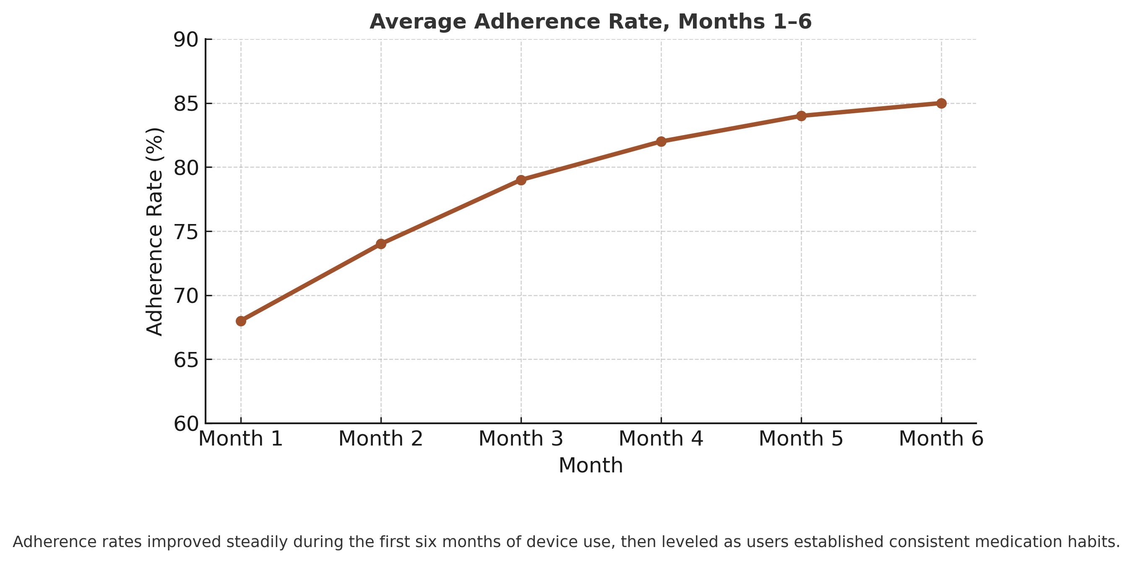
Adherence rates improved steadily during the first six months of device use, then leveled off as users established consistent medication habits.

Key Takeaway
The SmartDose case demonstrated that effective proposal writing requires more than technical accuracy — it demands empathy for the end user and translation of engineering into human impact.
“When science speaks in the language of care, reviewers listen.”

About the Author
Brad G. Philbrick, RPh, is a pharmacist-turned-writer specializing in biomedical innovation, healthcare communication, and grant proposal strategy. With over a decade of success in NIH and NSF proposal development, he assists research teams in transforming technology into fundable, patient-centered stories.

Confidentiality and Client Trust
In respect for confidentiality agreements (CDAs) and HIPAA compliance, all case studies are based on realistic composite scenarios drawn from professional experience. Names, data, and identifiers have been adapted to protect privacy while preserving the authenticity of results and lessons learned.

